Collections Interview Questions
Q.Why are generic collections preferred over non-generic collections?
Ans.
Generic collections provide type safety at compile time, reduce runtime errors, and avoid boxing/unboxing.

Q .Explain boxing and unboxing in the context of collections.
Ans.
- Boxing: Converting a value type to an object type (occurs in non-generic collections).
- Unboxing: Extracting the value type from the object.
Q .What are the differences between IEnumerable<T> and ICollection<T>?
Ans.
- IEnumerable<T>: Basic iteration functionality using foreach.
- ICollection<T>: Extends IEnumerable<T> with additional methods like Add, Remove, and Count.

- Discuss the performance differences between Array, ArrayList, and List when it comes to adding, deleting, inserting, and looping through elements in C# Collections?

Ans.

Array: Arrays are fixed-size and strongly-typed collections. As a result, the performance of arrays when accessing elements is very efficient , as no boxing or unboxing is required.

- Adding an element: Not directly supported. Requires manual array resizing, resulting in complexity.
- Deleting an element: Not directly supported. Requires shifting elements and manual resizing, resulting in complexity.
- Inserting an element: Not directly supported. Requires shifting elements and manual resizing, resulting in complexity.
- Looping through elements: Very efficient due to strong-typing and continuous memory allocation, which benefits CPU cache locality.

ArrayList: ArrayList is a dynamic-size collection that stores elements as object types, leading to boxing and unboxing overhead when working with value types.
- Adding an element: Amortized complexity.

- Deleting an element: complexity, as it requires shifting elements.
- Inserting an element: complexity, as it requires shifting elements.
- Looping through elements: complexity, with potential additional overhead from boxing and unboxing when accessing elements.

List: List is a dynamic-size and strongly-typed collection, which provides better performance than ArrayList, particularly when dealing with value types.

- Adding an element: Amortized complexity.
- Deleting an element: complexity, as it requires shifting elements.
- Inserting an element: complexity, as it requires shifting elements.

- Looping through elements: complexity, with efficient element access due to strong-typing and no need for boxing and unboxing.

In general, for most scenarios, List<T> is preferred over ArrayList due to its strongly-typed nature
and better performance with value types. Arrays are best suited for scenarios where the
collection size is fixed or known in advance, and memory usage and element access performance are crucial.

How does the C# SortedDictionary internally maintain its order, and how would you choose between using it and a SortedSet?

Ans.
Internally, SortedDictionary<TKey, TValue> is implemented as a self-balancing binary search tree (typically a red-black tree). This tree structure enables the dictionary to maintain order based on the key, and ensures that operations like insertion, deletion, and search have O(log n) time complexity.
When choosing between SortedDictionary<TKey, TValue> and SortedSet<T>, consider the following aspects:
- Purpose: Use SortedDictionary<TKey, TValue> when you need to associate keys with values and maintain the key-value pairs in a sorted order. Use SortedSet<T> when you need a non-duplicate collection of elements that are always sorted.
- Lookup: In SortedDictionary<TKey, TValue>, the lookups, insertions, and deletions are based on the key, whereas, in SortedSet<T>, these operations are based on the element itself.
- Memory: SortedDictionary<TKey, TValue> generally consumes more memory due to storing both keys and values, while SortedSet<T> only stores the elements.

3. Discuss the differences between a Stack and a Queue in C# Collections, and provide a real-world example of when each type would be most suitable.?

Ans.
- Stack: A Stack is a Last-In-First-Out (LIFO) collection, meaning the most recently added element is the first one to be removed. Main operations in a Stack include Push (to add an element to the top) and Pop (to remove the top element). Real-world example: A Stack is suitable for scenarios like managing the Undo and Redo functionality in a text editor or implementing function call stacks in programming languages.
- Queue: A Queue is a First-In-First-Out (FIFO) collection, meaning the oldest added element is the first to be removed. Main operations in a Queue include Enqueue (to add an element to the end) and Dequeue (to remove the front element). Real-world example: A Queue is suitable for scenarios like handling requests in a server, where each incoming request is queued and processed in the order they were received, or managing print jobs in a printer queue.
In summary, choose a Stack<T> when you need a LIFO behavior, and choose a Queue<T> when you need a FIFO behavior.

4. How can you implement a custom collection class that can be used as both a Dictionary and a List while maintaining the performance characteristics of both in C#?

Ans.
To implement a custom collection class that acts as both a Dictionary and a List, you can create a class that composes a List<T> for ordered storage and a Dictionary<TKey, TValue> for key-based lookups. This way, you preserve the performance characteristics of both collections in a single class.
Here’s an example of a custom class ListAndDictionary<T> that uses a key selector function to build the dictionary and utilize list functionality:
public class ListAndDictionary<TKey, TValue>
{
private List<TValue> _list = new List<TValue>();
private Dictionary<TKey, TValue> _dictionary = new Dictionary<TKey, TValue>();
private readonly Func<TValue, TKey> _keySelector;

public ListAndDictionary(Func<TValue, TKey> keySelector)
{
_keySelector = keySelector ?? throw new ArgumentNullException(nameof(keySelector));
}

public void Add(TValue value)
{
TKey key = _keySelector(value);
_dictionary.Add(key, value);
_list.Add(value);
}

public TValue GetByKey(TKey key) => _dictionary[key];

public TValue GetByIndex(int index) => _list[index];

public bool Remove(TKey key)
{
if (_dictionary.TryGetValue(key, out TValue value))
{
_dictionary.Remove(key);
_list.Remove(value);
return true;
}
return false;
}

public int Count => _list.Count;

// Implement other methods or properties as needed.
}
By combining both a List<T> and a Dictionary<TKey, TValue> in a single custom class, you can efficiently
access elements by key or by index and maintain the performance characteristics of both.

5. What are the performance considerations to take into account when choosing to implement a tree-based collection such as SortedSet or SortedDictionary, and how does its performance compare to a hash-based collection like HashSet or Dictionary?

Ans.
When choosing to implement a tree-based collection like SortedSet<T> or SortedDictionary<TKey, TValue>, some performance considerations should be taken into account:
- Lookup, insertion, and removal operations: For tree-based collections, operations like lookup, insertion, and removal have an O(log n) time complexity. In comparison, hash-based collections like HashSet<T> and Dictionary<TKey, TValue> offer, on average, constant-time (O(1)) complexity for these operations. As a result, hash-based collections generally provide faster performance for these operations.
- Sorting: Tree-based collections maintain a sorted order, which can be a beneficial feature if you require sorting. In contrast, hash-based collections do not guarantee any specific order and require additional sorting steps when needed.
- Memory consumption: Tree-based collections tend to have higher memory consumption than hash-based collections, as tree nodes require storing additional pointers for maintaining the tree structure.
In summary, prefer tree-based collections like SortedSet<T> or SortedDictionary<TKey, TValue> when maintaining a sorted order is a priority or a requirement. For general-purpose usage or scenarios where fast lookups, insertions, and removals are more important, consider using hash-based collections like
HashSet<T> or Dictionary<TKey, TValue>.

6. What are Generics in C#?
Ans.
Generics in C# allow you to create classes, interfaces, methods, and delegates with a placeholder for the data type. This enables you to design flexible and reusable code by specifying the actual data type when the code is used, ensuring type safety and performance improvements. Generics enhance code readability and maintainability by writing algorithms and data structures that work with any data type.

7. What is a Hash table class in C#?
Ans.
A hash table class in C# is a data structure that stores key-value pairs, providing fast retrieval of values based on their associated keys. It uses a hash function to map keys to indices in an internal array, allowing constant-time average complexity for basic operations like insertion, deletion, and lookup. The Hashtable class in C# is an implementation of a hash table, part of the System.Collections namespace, providing these functionalities.

8. Difference between SortedList and SortedDictionary in C#.
Ans.
SortedList a collection of key/value pairs that are sorted according to keys. By default, this collection sort the key/value pairs in ascending order. It is of both generic and non-generic types of collection.
SortedDictionary a generic collection that is used to store the key/value pairs in the sorted form and the sorting is done on the key.
Below are some differences between SortedList and SortedDictionary:
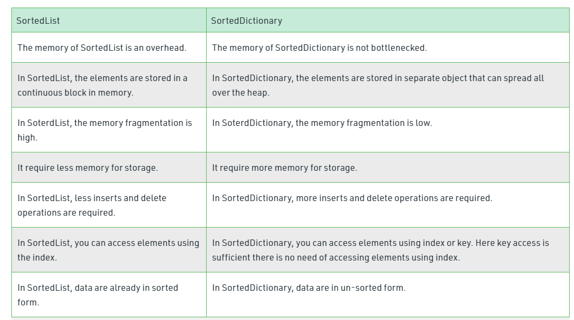

9. What is the difference between Array and ArrayList?

Ans.
An array is a group of like-typed variables that are referred to by a common name. ArrayList represents an ordered collection of an object that can be indexed individually. It is basically an alternative to an array. Below are the major differences

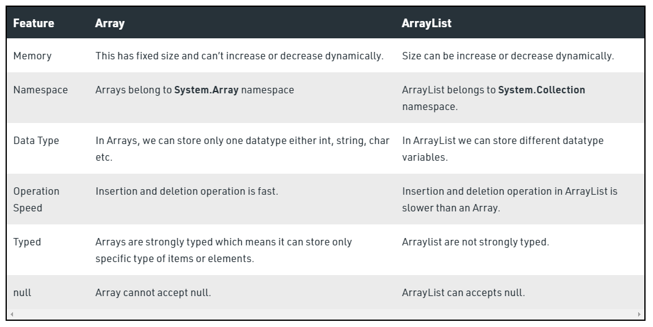

10. What is the difference between Queue and Stack?

Ans.
Aspect | Queue | Stack
Order | Follows FIFO (First In, First Out). | Follows LIFO (Last In, First Out).
Usage | Used where the first added element must be processed first. | Used where the last added element must be processed first.
Operations | - Enqueue: Adds an item to the end. | - Push: Adds an item to the top.
 | - Dequeue: Removes an item from the front. | - Pop: Removes the top item.
Typical Use Cases | - Task scheduling | - Undo functionality
 | -Print job management | - Expression evaluation (e.g., parsing parentheses)
 | - Breadth-first search in graphs | - Depth-first search in graphs

11. What is the difference between System.Collections and System.Collections.Generic?
Ans.
Feature | System.Collections | System.Collections.Generic
Introduced In | .NET Framework 1.0 | .NET Framework 2.0
Type Safety | No | Yes
Performance | Slower | Faster
Data Storage | Stores objects (object type). | Stores specified types.
Use Case  . | Legacy code, mixed data types. | Modern applications with type-safe needs
Common Classes | ArrayList, Hashtable, Queue, Stack. | List<T>, Dictionary<TKey, TValue>, Queue<T>, Stack<T>.

